The Praise Song Cruncher 2.5
A Tool for Assessing the Usefulness of Praise Songs

1. Jesus
Is Jesus Mentioned? If yes, is it in name or concept?
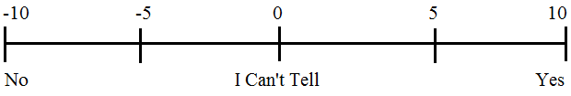
Score:

2. Mystical Form
Truth: Does the song use sentences (with subject, verb, and object) or sentence fragments? Is the song full of impressions or assertions? (Without sentences it is impossible to express truth.)
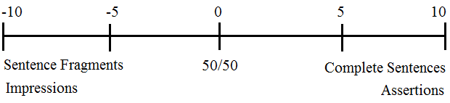
Score:
Repetition: Is the song repetitive, using the same phrases over and over? Is it very repetitive?
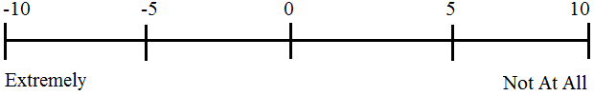
Score:

3. Mystical Content
Immediate: Does the song talk about an immediate experience of God (seeing, touching, feeling God directly)?
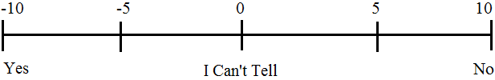
Score:
Romance: Does the song use romantic imagery?
Score:
Loss of Self: Does the song talk about losing our identity, being lost in God, absorbed, consumed, engulfed? Are we surrendering, abandoning ourselves, etc.?
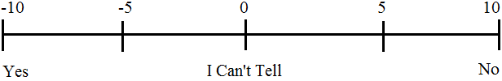
Score:
Internal: Is the action of the song, of God inside of me?
Score:
Subjective: Is the song about the things that God has done (objective), or about me (subjective)?
Score:
4. Law and Gospel
Proper Distinction: Does the song proclaim the law in its sternness and the Gospel in its sweetness? (The Gospel is the promise of the forgiveness of all sins won for us through Jesus’ death on the cross.) Are law and Gospel rightly divided (and not mixed up)? Is the law presented as something that we can do, or does it show us our sins? Is the Gospel conditional (based on my actions, decisions, or acceptance)? Is the power of God emphasized over the mercy of God?
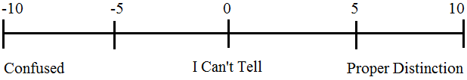
Score:
5. False Doctrine Not Already Addressed?
Yes: Score Automatically -100
No: +10
Final Assessment
Numerical Score (-100 to 100):
In theory: -100 to -50 not appropriate ever, -50 to 0 not appropriate for worship, 0 to 50 appropriate for the car, 50 to 100 appropriate for worship

Notes:
What we find in the praise songs we do not find in the Bible. In other words, the entire picture of what salvation is, who God is, etc., is skewed in Praise Songs.
The counter argument, then, is that the Bible does talk like the Praise Songs: in the Psalms, there is much emotion, the image of Bridegroom and Bride is romantic, etc.
The burden, then, is to show how mysticism is forbidden, or how the different aspects of mysticism are forbidden. It would also be helpful to have examples of mystical pagan worship.
The difference is between confessing a mystery and embracing a mystery (standing at the end of the cliff verses jumping off).
Also, how do you talk about movement? For Example: putting a person in motion verses placing them at the face of God.

